Git guide for uploading a Pull Request
by F. Estevez for PongamosHuevos's team

First time configuration

- You obviously need GIT. Download it and install it from here: http://git-scm.com/
- Go into https://github.com/matiasiacono/58Garages, and copy the clone URL link from here:
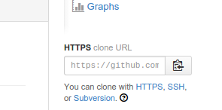

- Open up your command-line tool (“Terminal” in Linux and “Git Bash” in Windows).
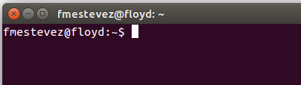

- cd to the desired folder where to download the project:
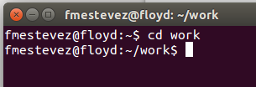

- Download the source code with git clone URL_COPIED_FROM_GITHUB, and press enter.
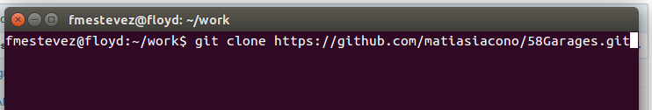

- cd to the resulting folder after the download is complete (in my case that would be
cd /home/fmestevez/work/58Garages/).
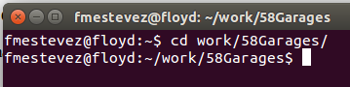

Everyday procedure

- While you are located in the project's folder, and BEFORE start working, execute git pull –rebase
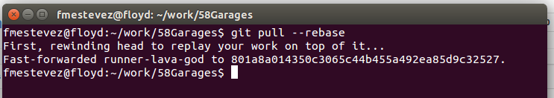

- Now, create a new branch, with a descriptive name, with git checkout -b my-branch
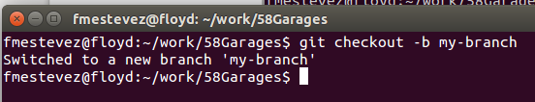

- WORK (do everything you need to do, obviously inside the project's folders).
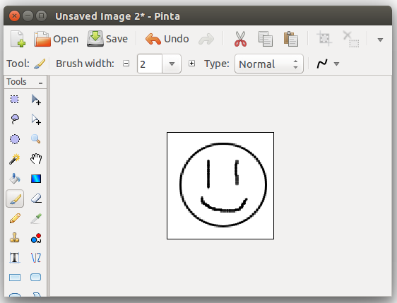

- When you are done, check your changes with git status (ignore the runner-lava-god folder here)
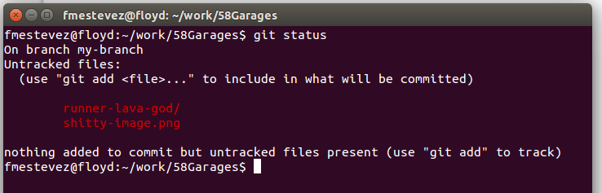

- Add the files you want to upload with git add FILENAME, and check you have all the files you need added with git status
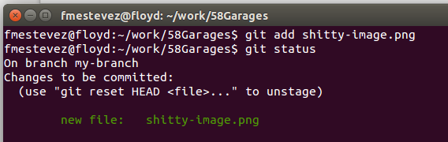

- Commit the files locally, with git commit -m “Mi Name – Description of what I did”, and press enter.
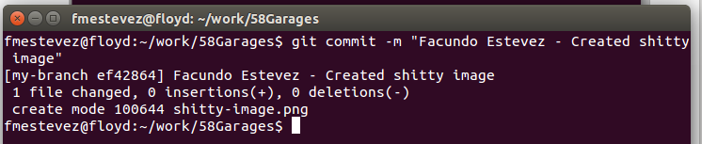

- Push the changes into the repository with git push origin MY_BRANCH_NAME (it has to be the exact same name of your branch). This will ask you your GitHub's credentials
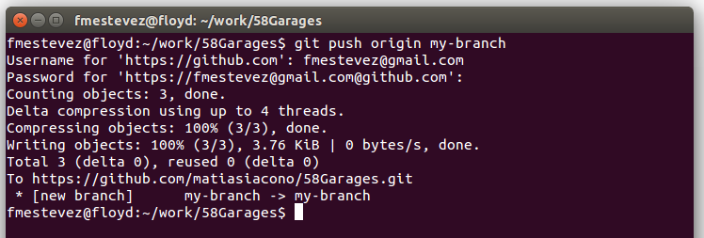

- Go into our GitHub's repository (https://github.com/matiasiacono/58Garages). You will see a notification with the branch you just uploaded. Click on “Compare & pull request”


- You will be presented with a diff of your changes. Review everything is right, and press on “Create pull request”
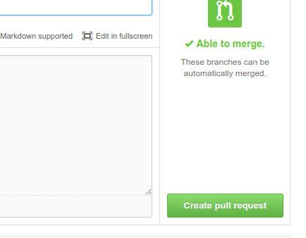

- THAT'S IT. Wait for your coworkers to review what you did, and decide to merge the pull request. Take into account that comments can be made into the PR. Keep your email on watch.

For more info, read this book: http://git-scm.com/book (in fact, if you read it, it would be awesome and helpful to the team).

